「APPETIZER HACKATHON 2022」 Guide

1 |  | Overview

□ Overview
○ Title: APPETIZER HACKATHON 2022

Theme
New Normal in the POST-COVI-19 Era,
The Beginning of Innovation using Cloud

○ Participants:
(Participation Eligibility):
(International) For university (graduate) students around the world, developers, companies, start-ups, etc.
(Korean) For Korean start-ups that have expanded into overseas markets and overseas inbound start-ups
(Selected candidates) A total of 30 teams are selected through the application process and document evaluation each forming a team of 1 to 5 people.

○ Main Contents: Each of the 30 teams that have advanced to the HACKATHON Programs participate in the idea and prototype development of HACKATHON using APIs of various Korean API companies and receive technical support and feedback through mentoring with API participating companies. 8 teams that are determined to have submitted excellent prototypes will be selected for final presentation and awards.

○ Prize: Total $ 27,000
- 1st place (1 team): $ 5,000 / 2nd place (2 teams): $ 3,000 each / 3rd place (5 teams): $ 1,000 each- There will be a $500 participation prize for the 22 teams that did not receive an award.

○ Major Benefits provided to participating teams
- About $2,500 of NAVER CLOUD credits for the 30 teams that advance to the
finals
- About $17,000 of NAVER CLOUD credits for the team that wins 1st place in HACKATHON, which can be used for up to one year
○ Registration Period
- September 15, 2022 (Thu) 09:00 AM ~ October 07, 2022 (Fri) 17:00 PM

○ How to Register: Apply online (www.api-appetizer.com)
- Only participating teams who have uploaded their development plan, Pledge of participation, and consent form for personal information collection, use, provision, and third-party provision will be accepted.
- There are APPLE-related prizes for the first 10 teams - registered during 09/15 ~ 09/23 and participate all hackathon programs by the end of the November, 2022.

○ Host / Organizer / Sponsor:
NAVER CLOUD / Korea Software Industry Association / Ministry of SMEs and Startups, Korea Foundation for Cooperation of Large & Small Business, Rural Affairs

2 |  | Event poster
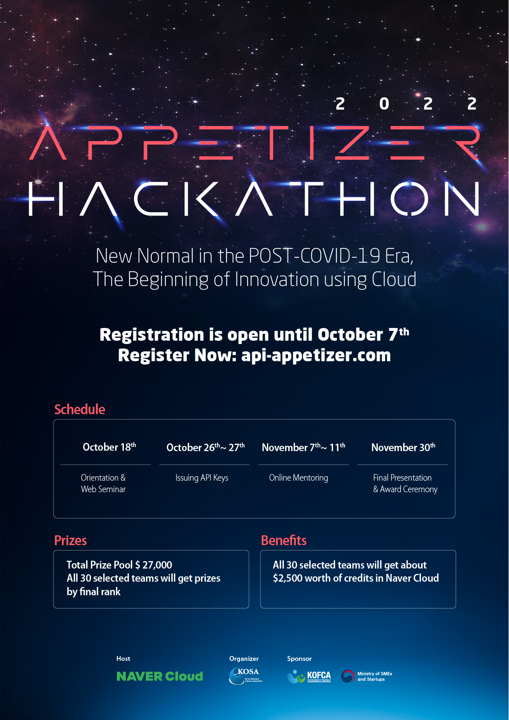
3 |  | Main schedule

□ Main schedule (Korean Local time)
Date |  |  | Program | Details
2022.09.15 (Thu) 09:00 ~ 2022.10.07 (Fri) 17:00 |  |  | Registration | · Apply online through HACKATHON website (api-appetizer.com)  · Submission of participation application, development plan, personal information agreement, etc.
2022.10.12 (Wed) ~ 2022.10.13 (Thu) |  |  | Document Evaluation | · Document evaluation for selection of 30 teams that will advance into main Hackathon round.
2022.10.14 (Fri) 17:00 |  |  | Announcement of Hackathon Participants | · Announcement of the 30 teams participating in the Hackathon programs
2022.10.18 (Tue) |  |  | Orientation and Web Seminar | · Orientation and Web Seminar for the 30 teams (Zoom)
2022.10.24 (Mon) 17:00 |  |  | Individual Mentoring Application | · Application for mentoring with API participating companies only for requesting teams.
 |  |  | API final choice | · Final selection of APIs to be used in HACKATHON
2022.10.26 (Wed) ~ 2022.10.27 (Thu) |  |  | Issuing API Keys | · Issuance of KEY using the final selection API
2022.11.07 (Mon) ~ 2022.11.11 (Fri) |  |  | Online Mentoring | · Online mentoring between the mentoring team and API participating companies (ZOOM)
2022.11.22 (Tue) 17:00 |  |  | Submission of pre-recorded presentation video and prototypes | · Submission of video presentations and prototypes of 30 teams participating in the HACKATHON program
2022.11.23 (Wed) ~ 2022.11.24 (Thu) |  |  | Presentation Video Evaluation | · Presentation video evaluation of the 30 teams and 8 teams selected for finals
2022.11.25 (Fri) 17:00 |  |  | Announcement of Final Teams | · 8 teams will be announced for the Final Presentation
2022.11.30 (Wed) |  |  | Final Presentation and Awards Ceremony | · Live Presentation of the final 8 teams  · Final ranking announcement and Awards Ceremony  · 1st place (1 team), 2nd place (2 teams), 3rd place (5 teams) selection
4 |  | Judging process and standard

□ Judging Process
Final Presentation and Awards Ceremony
(8 final teams
to be ranked)
Presentation Video Evaluation
(8 teams to advance
to the Finals)
Document Evaluation
(30 participants selected)

→

□ Judging Method and Standard
○ Document Evaluation (Selection of 30 participants)
- Will proceed when more than 30 teams are registered, including the
evaluation of each development plan submitted at the time of HACKATHON
- Selection of the top 30 teams by determining the average of the judges' scores
for each element
- Evaluation factors (100 points): Differentiation and originality of ideas
(30 points), API utilization (30 points), Possibility of implementation (30 points),
expected effectiveness (10 points)
○ Presentation Video Evaluation (8 teams to advance to the finals)
- Evaluation of the pre-recorded and demonstration videos submitted by each
of the 30 teams
- The 8 teams which will advance to the finals are selected by determining the
average of the judges' scores for each element
- Evaluation factors (100 points): Differentiation and originality of ideas
(25points), API utilization (25 points), goal achievement and implementation
ability (30 points), expected effects (10 points), presentation delivery ability
(10 points)
○ Final announcement and awards (Ranking)
- The 8 teams that have advanced to the finals will present real-time online
presentations
- The final ranking of these 8 teams is determined through final screening
- Evaluation factors (100 points): Presentation video evaluation score (50
points), prototype evaluation score (30 points) Presentation delivery ability
(20 points)

5 |  | Inquiries

□ Inquiries: Secretariat of APPETIZER HACKATHON

[E-Mail] yr@prime-c.co.kr

* For inquiries, please contact us through the email above, Inquiry on the website, or whatsApp.

『APPETIZER HACKATHON』
Detailed Criteria for Document Evaluation
Category | Evaluation item | Detailed item
Judge Evaluation  [100 points] | Differentiation and originality of development services (30 points) | ⦁ Relevance of development services and topics
Judge Evaluation  [100 points] |  | ⦁ Originality of development services
Judge Evaluation  [100 points] |  | ⦁ Excellence in development services
Judge Evaluation  [100 points] | API Utilization  (30 points) | ⦁ Feasibility of using the API
Judge Evaluation  [100 points] | API Utilization  (30 points) | ⦁ Excellence in API utilization
Judge Evaluation  [100 points] | API Utilization  (30 points) | ⦁ Appropriateness of development service and API use
Judge Evaluation  [100 points] | Implementation Feasibility  (30 points) | ⦁ Specificity of development goals and development  contents (method, period, etc.)
Judge Evaluation  [100 points] | Implementation Feasibility  (30 points) | ⦁ Adequacy of the development promotion system
Judge Evaluation  [100 points] | Implementation Feasibility  (30 points) | ⦁ Implementation feasibility of the proposed service
Judge Evaluation  [100 points] | Expectation Effectiveness  (10 points) | ⦁ Expected ripple effect related to the development  field

『APPETIZER HACKATHON』
Detailed Criteria for Presentation Video Evaluation
Category | Evaluation item | Detailed item
Judge evaluation  [100 points] | Differentiation and originality of development services  (25 points) | ⦁ Relevance of the development services and related  topics
Judge evaluation  [100 points] |  | ⦁ Originality of the development services
Judge evaluation  [100 points] |  | ⦁ Excellence in development services
Judge evaluation  [100 points] | API Utilization  (25 points) | ⦁ Feasibility of using the API
Judge evaluation  [100 points] | API Utilization  (25 points) | ⦁ Excellence in API utilization
Judge evaluation  [100 points] | API Utilization  (25 points) | ⦁ Ideas and API usability and suitability
Judge evaluation  [100 points] | Goal Attainment and Implementation Ability  (30 points) | ⦁ Fidelity in achieving development goals
Judge evaluation  [100 points] | Goal Attainment and Implementation Ability  (30 points) | ⦁ Comprehensiveness of the implementation of the  development service (prototype)
Judge evaluation  [100 points] | Goal Attainment and Implementation Ability  (30 points) | ⦁ Realistic implementation possibilities of the  development services
Judge evaluation  [100 points] | Expectation Effectiveness  (10 points) | ⦁ Ripple effect related to its development field
Judge evaluation  [100 points] | Expectation Effectiveness  (10 points) | ⦁ Sustainability and scalability of the proposed service
Judge evaluation  [100 points] | Presentation delivery ability  (10 points) | ⦁ Fidelity of the presentation contents
Judge evaluation  [100 points] | Presentation delivery ability  (10 points) | ⦁ Deliverability of the presentation content

『APPETIZER HACKATHON』
Detailed criteria for final presentation evaluation
Category | Evaluation item |  | Detailed item
Judge evaluation  [100 points] | Presentation video evaluation score  (30 points) |  | ⦁ Reflection of the presentation video evaluation  score
Judge evaluation  [100 points] | Final prototype evaluation (50 points) |  | ⦁ Implementation comprehensiveness (prototype)
Judge evaluation  [100 points] |  |  | ⦁ Effectiveness of implementation of development services (Commercialization, scope of application, etc.)
Judge evaluation  [100 points] | Presentation delivery ability  (20 points) |  | ⦁ Fidelity of the presentation contents  ⦁ Deliverability of presentation content

